Chapter
X

POLYMERIC MICELLES FOR CUTANEOUS DRUG DELIVERY
Sevgi GÜNGÖR, Emine KAHRAMAN, Yıldız ÖZSOY
Istanbul University, Faculty of Pharmacy, Department of Pharmaceutical Technology, 34116, Universite, Istanbul, Turkey
Contents
Introduction
Micelles
Polymeric micelles
Micelle-forming copolymer
Types of polymeric micelles
Preparation of polymeric micelles
Factors affecting the drug loading capacity of the micelles
Characterisation of micelles
Micelles for Drug Delivery via Skin
The structure of human skin
The skin penetration pathways
Applications of polymeric micelles as drug carrier in topical treatment
Cyclosporine
Tacrolimus
Sumatriptan
Endoxifen
Oridonin
Clotrimazole, Econazole nitrate and Fluconazole
Benzoyl peroxide
Retinoic acid
Quercetin and Rutin

Introduction

Polymeric micelles are nano-sized colloidal carriers which assemblies of nanoscale size. They are composed of amphiphilic block polymers and characterized by core-shell morphology formed through self-association of hydrophilic and hydrophobic block copolymers in water. Micelles can increase the aqueous solubility of hydrophobic compounds in their inner cores. They have also other advantageous including improvement of chemical stability of drugs, easy scale-up procedure for industrial production. Therefore, micelles have been widely investigated as nasal, ocular, and skin delivery of drugs to overcome the natural transport barrier of biological membranes.
In recent years, different type of nano-sized carriers has been widely investigated for cutaneous delivery of drugs. Micellar carriers have also been explored for topical delivery of drugs via skin. Cutaneous delivery of drugs, particularly for the treatment of skin diseases would benefit in terms of improving aqueous solubility of hydrophobic drugs, targeting of drugs into skin layers, controlling release rate of drugs, decreasing side-effects of the drugs such as irritation, and keeping the drugs from environmental factors (oxidation, etc.). Thus, nano-sized polymeric micelles have been considered as a promising drug carrier for the effective treatment of some skin diseases.
The chapter deals with overview of polymeric micelles as nano-sized carrier for skin delivery of drugs. Micelle-forming copolymers, types of polymeric micelles, preparation of polymeric micelles, the factors affecting the drug loading capacity of the micelles and characterisation of micelles are emphasized. Skin structure and penetration pathways are also briefly reviewed to give background information. Finally, the recent research studies in which micelles developed for targeting cutaneous delivery of drugs to skin are summarized.

Micelles
Micelles, created from two different regions with opposite affinities towards a particular solvent, are "aggregated colloids" between 5 and 200 nm in size, which are spontaneously formed from amphiphilic or surfactant agents at a defined concentration and temperature. Amphiphilic molecules, while found separately in an aqueous solution with low concentration, create aggregation of micelles as the concentration is increased. This monomeric amphiphilic concentration at which micelles are observed is called as "critical micelle concentration" (CMC) [1]. Below the CMC, the concentration of amphiphiles adsorbed at the water/air interface increases as the total system amphiphile concentration increases. After a period of time the interface and system monomers become saturated and CMC is obtained. Any amphiphiles added after this concentration has been reached assemble to form micelles in the system, and thus the free energy reduces in the system.
Micelles are nano-sized colloidal carriers with a hydrophobic core and hydrophilic shell (Fig. 1). While the core acts as a reservoir for hydrophobic drugs, the shell of micelle provides hydrophilic properties to the system [2, 3].

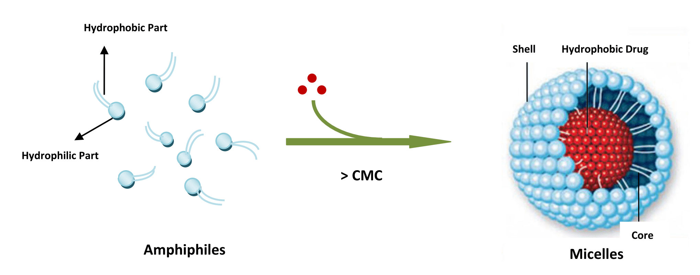

Figure 1. The formation of drug loaded micelles

Depending on the weight of the molecule, these systems can be divided into two groups; low molecular weight surfactant micelles, and polymeric micelles [4]. Polymeric micelles formed through the use of amphiphilic copolymers have a lower CMC compared with surfactant micelles. Therefore, they are more stable under in vivo conditions [5, 6]. Another advantage of polymeric micelles is their lack of serious side effects [7].

Polymeric micelles
Polymeric micelles are composed of block copolymers consisting of hydrophilic and hydrophobic monomer units. In some special cases, the components of copolymer may also be consisted of two hydrophilic blocks. One of these blocks is modified by coupling it with a hydrophobic agent (such as taxol, cisplatin or hydrophobic diagnostic agents) and an amphiphilic copolymer formed micelle occurs [8]. By controlling the length of the hydrophilic/hydrophobic blocks, copolymers of differing HLB and molecular weights can be synthesized. The physicochemical and biological properties of the copolymers can be controlled by the molar ratios of the different blocks inside the copolymers. The aggregation number of polymeric micelle is approximately a few hundred amphiliphiles, dependent on size, and have diameter within the range of 10-100 nm. The size of the micelle is dependent on relative proportion of hydrophilic and hydrophobic chains, the amphiphilic block copolymer's molecular weight and the number of amphiphiles aggregations [5, 9].
Polymeric micelles provide several advantages such as having nano-size, easy of scale-up studies, increased drug solubility and chemical stability. Given these advantages, there has been much research in their use as drug and gene delivery systems via parenteral [10, 11], oral [12, 13], nasal [14, 15], ocular [16, 17] and topical/transdermal [18, 19] applications.

Micelle-forming copolymers
Polymeric micelles made from amphiphilic blocks (di - or tri) or of graft copolymers (Fig. 2) have received a lot of attention in recent years [7, 20]. For synthesized copolymers to form micelles, there needs to be a balance between the hydrophilic blocks forming the micelle shell and the hydrophobic block forming the core. For this reason, some simple arrangements are made for the amphiphilic unimers.
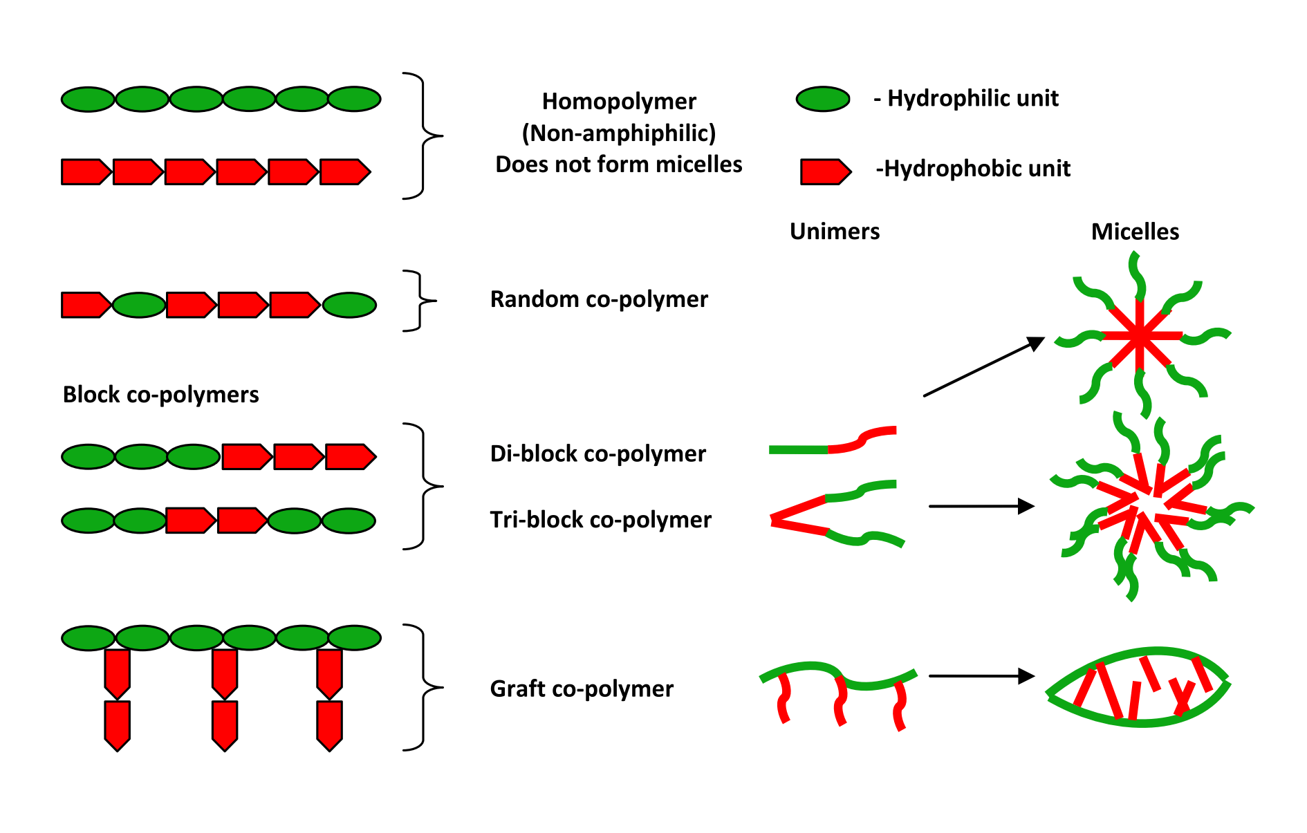

Figure 2. Main structural types of co-polymers and micelles formed from amphiphilic co-polymers [21]
For example, PEG blocks with a molecular weight of 1-15 kDa should be used to form shell part, while the length of the hydrophobic block forming the core should be around the same length or slightly shorter than the hydrophilic block [7].
The most of amphiphilic block copolymers contain polyester, polyether or a poly(amino acid) derivative as hydrophobic block. Generally, the hydrophobic core comprises of a biodegradable polymer such as poly-ԑ-caprolactone (PCL), poly (D, L-lactic acid) (PDLL) or poly (β-benzoyl-L-aspartate) (PBL A), and acts as a reservoir for drugs with poor water solubility and protects them from contact with the aqueous medium. The block which forms the core can also be a water-soluble polymer rendered hydrophobic by the chemical conjugation of a hydrophobic drug (e.g. polyaspartic acid, P (Asp)); or polystyrene with good stability given its glassy properties (Pst) or a non-biodegradable polymer such as poly(methyl methacrylate) (PMMA); or an alkyl chain or a diasillipid (e.g. distearoyl phosphatidyl ethanolamine (DSPE)) [5].
The hydrophilic polymer forming the shell of the polymeric micelle is responsible for the interaction with cell membranes and providing effective steric protection for micellar structure. The shell structure determines the hydrophilicity, charge, size of the micelles; the surface density of the hydrophilic block and presence of the suitable reactive group for the addition of targeting molecules. These characterisations control the important biological properties of the micellar carriers, such as pharmacokinetics, biodistribution, biocompatibility, circulation time in the blood, the surface adsorption into biomacromolecules, adsorption into bio-surfaces and targeting [6, 7]. Poly (ethylene glycol), with high solubility in water and the ability to easily combine with hydrophobic blocks, is usually used as the hydrophilic block. In addition, polyacrylamide, polyhydroxyethylmethacrylate, poly(N-vinyl-pyrrolidone) (PVP) and poly(vinyl alcohol) (PVA) can also be used as the hydrophilic block [5, 7, 20].
The physicochemical and biological properties of the copolymer can be controlled by the molar ratios of the different blocks inside the copolymer. Furthermore, the proper arrangements for a specific focus can be made by modifying core functions and surface chemistry [5, 7].
Types of polymeric micelles: Polymeric micelles, which resist the various intermolecular forces and keep the core separate from the aqueous medium, can be divided into three categories.
Conventional micelles: These micelles are formed by the hydrophobic interaction between the core and the shell in the aqueous medium. One of the simplest amphiphilic block copolymers, poly (ethylene oxide)-β-poly (propylene oxide)-b-poly (ethylene oxide) forms micelles as a result of hydrophobic interactions [22].
Polyion complex micelles: Like polyelectrolytes, the electrostatic interactions between two oppositely charged parts also allow the formation of micelles. Oppositely charged polymers penetrate the shell of the micelles when added to the solution and the formation of polyion micelles occurs. Electrostatic forces and van der Waals interaction forces control the shell structure and size of the charged micelle. These micelles easily and spontaneously occur in aqueous media, are structurally stable and have a high drug loading capacity.
Noncovalently connected polymeric micelles: Here, polymeric miselles are obtained by self-assembly of random copolymer, graft copolymer, homopolymer or oligomer are, powered by the driving force of interpolymer hydrogen bonding complexation. The core and shell are non-covalently connected by the ends of their homopolymer chains, either through intermolecular interactions such as H-bonding, or metal-ligand interactions occurring in their structure, and as such are known as non-covalently connected polymeric micelles [22].
Preparation of polymeric micelles: Simple equilibrium, dialysis, O/W emulsion, solution casting and freeze-drying methods are used in the preparation of polymeric micelles [23] (Fig. 3).

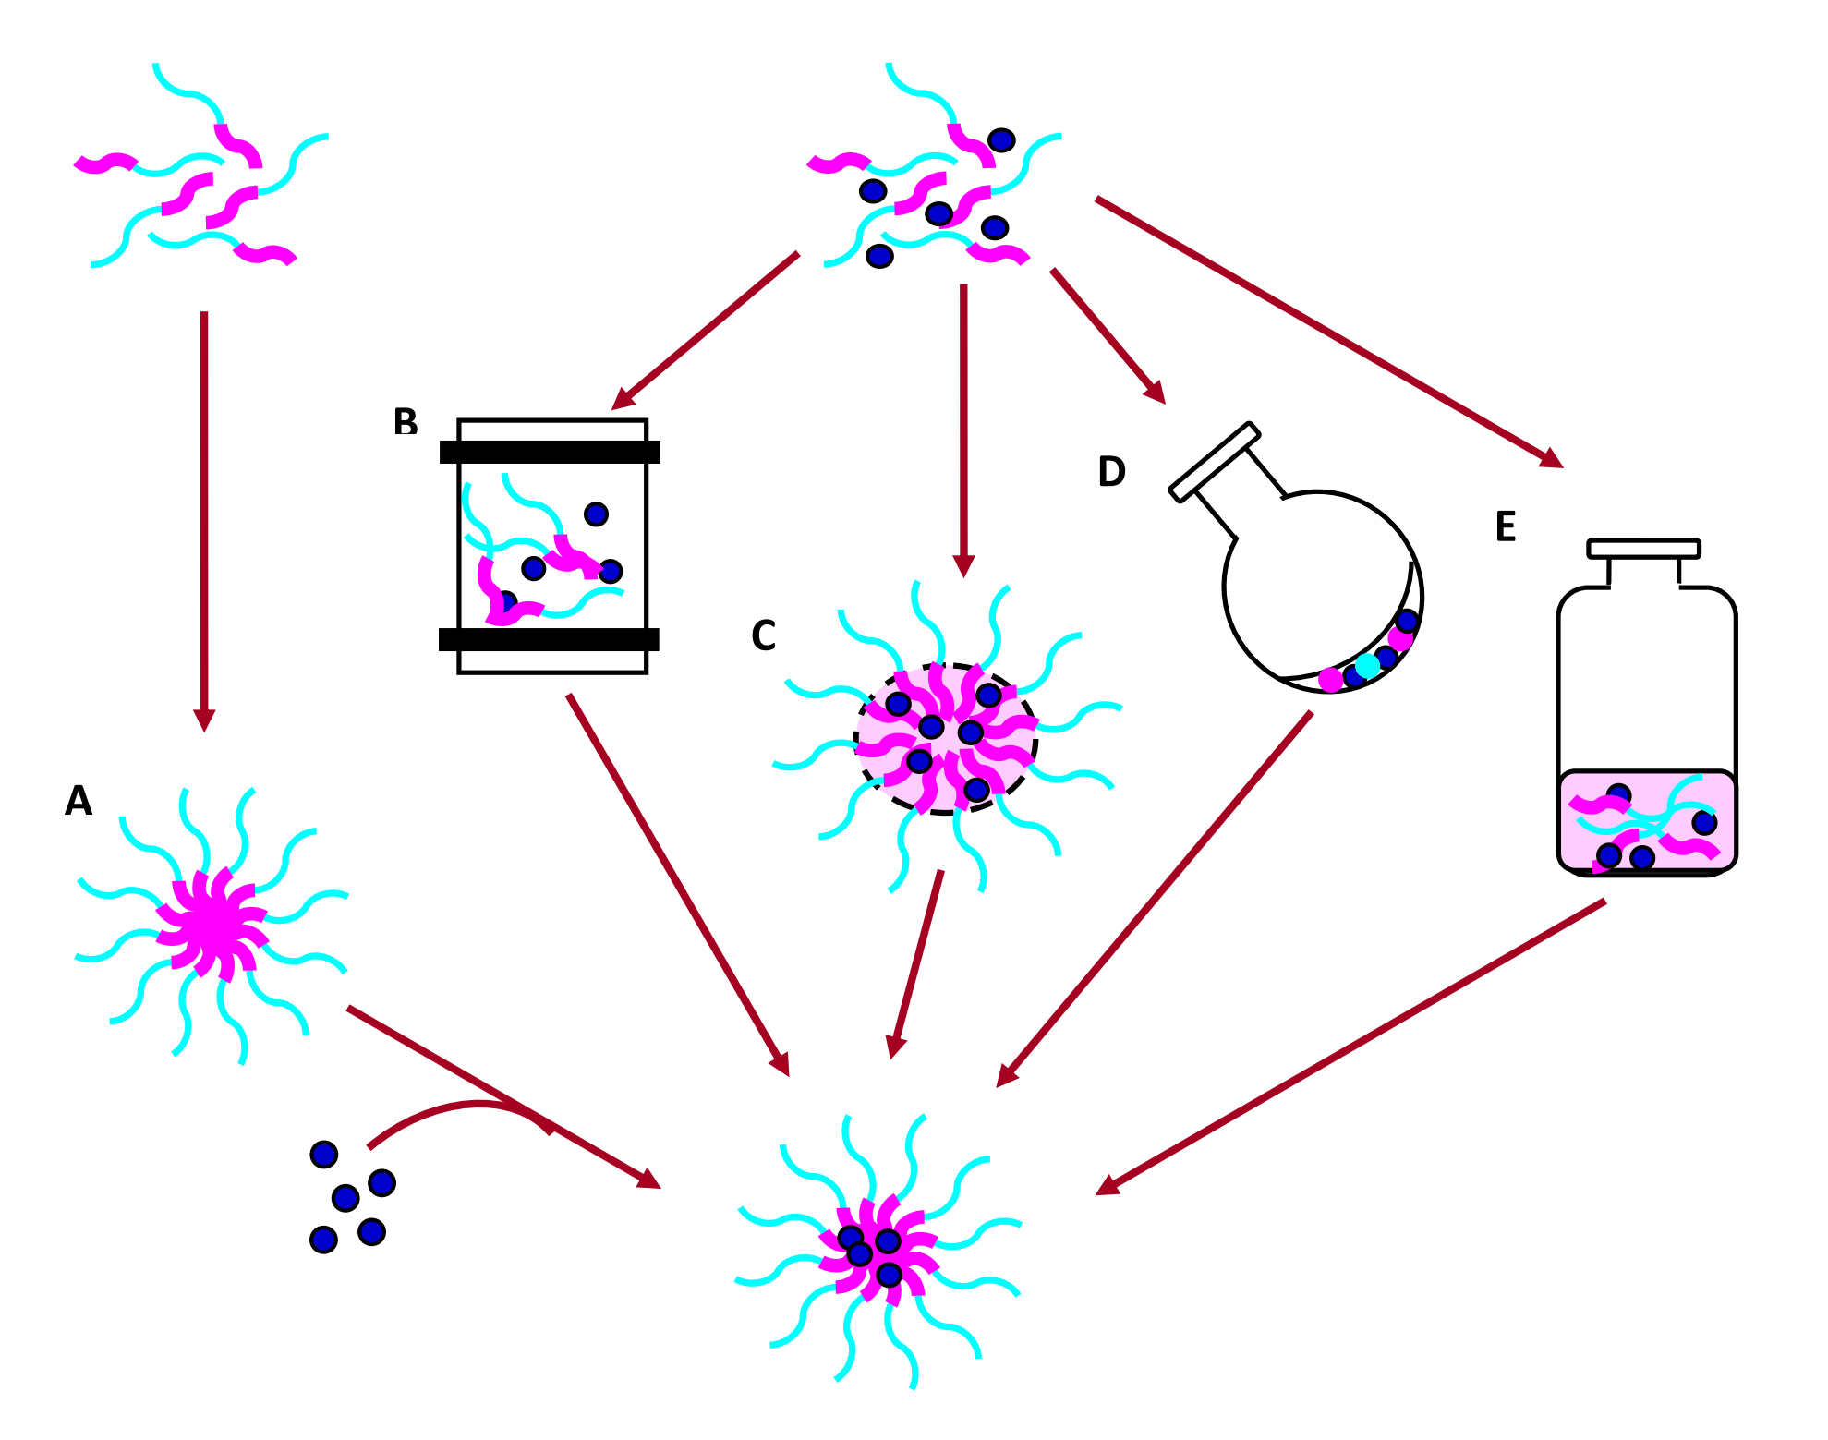

Figure 3. Common drug-loading procedures: (A) simple equilibrium, (B) dialysis, (C) O/W emulsion, D) solution casting, and (E) freeze-drying [23]
If the block copolymer is water-soluble, the simple equilibrium method is used; if not, the dialysis method [7]. While the drug is loading into the micelles, its physicochemical properties is crucial. Hydrophobic drugs can be loaded into the micelle by chemical or physical interactions [5, 23]. In order to load hydrophilic compounds such as proteins into the micelles, the molecule should be made chemically hydrophobic. In order to load ionically drugs into the micelles, there must be an opposite charge on the surface of the copolymers' hydrophobic block. In the event that a drug is to be chemically or electrostatically bound to the hydrophobic block, the formation of micelles and their combination with the drug should be carried out simultaneously. Strong polymer-drug interaction increases the load on the micelle core, but reduces the micelles’ drug release. For this reason, the loading amount and drug release kinetics must be optimized. In addition, micelles have been obtainable through microfluidic technology in recent years [24].

Factors affecting the drug loading capacity of the micelles
There are many factors that affect the loading capacity of hydrophobic drugs to the micelle-forming amphiphilic copolymers. These factors are summarized below.
Factors belongs to copolymer
The copolymer concentration, the length and hydrophobicity of the blocks forming the core, and the structure and length of the block forming the shell affect the loading capacity of micelles [25]. An increase in the copolymer concentration, hydrophobic block length and hydrophobicity of the core increases the loading capacity. When the length of the hydrophilic block is increased, the CMC also increases and the loading capacity decreases. Also, by affecting the hydrophobic/hydrophilic balance of the drug molecule, it determine where the drug core or shell are placed and the loading capacity. Drug molecules situated on or close to the micelle shell are released quickly. For this reason, in order to delay the release of the drug, the drug molecules should be dissolved in the core of the micelle or be loaded to the core in a separate phase [20].
Interactions between the drug and the micelle core (hydrophobic, hydrogen bonding, ionic interactions, etc.)
These interactions depend on properties such as the polarity, hydrophobicity and charge of the drug. Sometimes, the interaction between the drug, hydrophilic shell, and soluble drug can also affect the dissolution process either positively or negatively [7, 20].
Micellar preparation methods and process-specific parameters (such as the structure of the organic solvent, solvent ratio) affect the drug loading capacity [20].
The polymer-drug miscibility is a crucial parameter for drug loading capacity of the micelles. Hildebrand-Scarchard solubility parameters are mostly used for this [26] and drug loading capacity can be calculated using the following formula called as the Flory-Huggins theory. If the Flory-Huggins parameter is a low value (<0.5), it signifies that the drug is well dissolved in the core of the polymeric micelle.
X_{drug-polymer}=(V_{drug}/ RT) (δ_{drug} - δ_{polymer})²
Where; X_{drug-polymer} is the Flory-Huggins interaction parameter between the drug and the polymer, V_{drug} is the volume of the drug, R is the ideal gas constant, T is the temperature, and δ_{drug} and δ_{polymer} are the Hildebrand-Scarchard solubility parameters of the drug and the polymer, respectively [27, 28].

Characterisation of micelles
Size and size distribution
One of the most interesting properties of polymeric micelles is their small size. A Micelle's size rarely reaches 100 nm. This situation depends on factors including the relative proportions of hydrophobic and hydrophilic chains, the number of amphiphile aggregations, the molecular weight of the amphiphilic copolymer and the micelle preparation method [5]. Also, in the study conducted by Kim and his colleagues [29], the solvent used to form micelles was also found to affect the size and size distribution of micelles. The hydrodynamic size and polydispersity of micelles can be measured by dynamic light scattering (DLS) in an isotonic buffer or in the water. The micelle size can also be calculated using atomic force microscopy (AFM), transmission electron microscopy (TEM) or scanning electron microscopy (SEM) studies. These methods also allow the micelle size distribution and morphology to be characterized [5, 30].
Morphology
It is generally accepted that there are spherical particles with a clear distinction between the micelle core and shell. In aqueous media, amphiphilic block copolymers self-aggregate towards spherical, worm-like or cylindrical micelles, polymer vesicles or polimersomes. Here, the main factor controlling micelle morphology is the hydrophilic volume fraction (f) defined by the hydrophilic-hydrophobic balance of the block copolymer [22]. Along with this, the copolymer aggregation, the organic solvent used to prepare the micelles, and the copolymer composition can be considered the main morphogenic factors [7].
Zeta potential
The stability of the colloidal particles is the basic parameter with regards to the ζ-potential of micelles. Moreover, it is also affected by interactions of biological elements such as cell membranes (which defines cell uptake and the particles’ pharmacokinetics) and proteins [31]. Generally, the absolute value of the zeta potential is 20-50 mV. The colloidal particles' charge is also very important in terms of system stability. In many cases, with a higher zeta potential value, there is stronger repulsive interaction between the surface charge of the colloidal particles and dispersed particles, and as such higher stability and a more uniform diameter is observed [32].
Stability
The determination of the stability of polymeric micelles is important for their characterizations, and their stabilities can be examined as thermodynamic stability and kinetic stability. The thermodynamic stability is crucial for in vivo conditions while the kinetic stability is for in vitro.
The thermodynamic tendency which breaks the individual chains of the micelles reflect the copolymer micelle concentration (CMC) [20]. When the polymer concentration is above the critical micelle concentration in the aqueous medium, the polymeric micelles are thermodynamically stable. If below the critical micelle concentration, the amphiphilic block copolymers in the aqueous medium are found to have single chains in the bulk phase at the air-water interface. When the polymer concentration is increased above the critical micelle concentration, as a result of the hydrophobic interactions between the hydrophobic blocks, amphiphiles self-aggregate and the system's Gibbs energy (ΔG) is reduced to the lowest level [9].
The kinetic stability of a micelle system is related to the single polymer chains’ exchange rate between the bulk and micelles. If the block forming the micelle core is semi-crystalline, the structure of the micelle is dependent on the glass transition temperature (Tg) and/or the Tm, and even at dilution levels below the CMC, the micelles remain kinetically stable for a long period of time. The dissociation speed of the micelles is related to the strength of interactions in the micelle core. Those interactions are dependent on factors such as the physical structure of the polymer comprising the core (crystalline or amorphous); the presence of the solvent in the micelle core; the length of the hydrophobic block; the hydrophilic/hydrophobic block ratio; and the encapsulation of hydrophobic compounds [20, 23].
To avoid stability problems, polymeric micelles should have a glassy or crystalline core at their preferred body temperature, and should be formed of copolymers with a low CMC [9].With the end goal of increasing the thermodynamic and kinetic stability of drug-loaded micelles by reducing the CMC, it has been discussed that approaches such as increasing physical interaction/covalent cross-linking, modifying the micelle-forming polymers, and enhancing drug-polymer interactions [23].
In briefly, stability tests of micellar solutions consists of observing whether or not there was any basic phase dispersion, determining particle size in order to ascertain aggregation, and analytically measuring the concentration of drug and block copolymers in the formulation [5, 7].

Micelles for Drug Delivery via Skin

The structure of human skin
Human skin is a well-designed unique membrane and, its fundamental functions are to protect organism from environmental factors and, to regulate transepidermal water loss from body. Histologically, it is composed of three main layers namely the epidermis, the dermis, and the hypodermis (subcutaneous tissue) [33-35]. The epidermis is also divided into two layers called as stratum corneum and viable epidermis. The stratum corneum is consisted of corneocytes which are dead, flattened, keratin-rich cells. The corneocytes are embedded in the mixture of intercellular lipids. Particularly, the stratum corneum, the outermost layer of epidermis, is an extremely effective barrier for the penetration of most drugs due to its excellent structure. It behaves as a rate-limiting barrier for diffusion for almost all drugs due to its well-ordered structure [36, 37]. In topical treatment, in most cases drugs should pass the stratum corneum to reach deeper layers of the skin for the efficiency of therapy. But, the main problem in the effective skin delivery is the low diffusion rate of drugs across the stratum corneum. As well as the physicochemical characteristics of drugs, the features of topical formulation are also an effective parameters in dermal drug delivery. Thus, to overcome barrier characteristics of skin for the improvement of cutaneous drug delivery is the major challenge [38-40].

The skin penetration pathways
The drugs pass through the skin barrier via three potential pathways, which are called as transcellular, intercellular and/or transappendageal (shunt) routes (hair follicles, sweat glands, and sebaceous glands) [33, 34, 41]. The contribution of each pathway for the permeation of drugs across the skin is mainly related to the physicochemical properties of drugs. While intercellular route has been regarded as the main transport pathway of most drugs and, the transcellular route becomes more important as a polar route. Since the appendages like hair follicles and glands called to be shunt pathway comprises only 0.1% of the human skin surface area, its contribution to skin penetration is considered as less significant. It was suggested that shunt route may provide advantageous the delivery of polar and ionized drugs that would not be easily delivered via lipid domain of stratum corneum [33, 34, 41, 42]. It was also indicated that transport pathways for penetration of topically applied drugs could be important in targeting the skin appendages, in particular targeted follicular delivery. Follicular penetration is suggested as a possible pathway for the rigid particulate carriers [43-46]. Prow et al. indicated that nanoparticles (>10 nm) are unlikely to penetrate across stratum corneum and the nanoparticles would accumulate in the hair follicle openings [47]. They emphasized that the topical delivery of nanoparticles through skin are occurred in three major sites including stratum corneum surface, furrows, and openings of hair follicles (infundibulum) (Fig. 4). On the other hand, it was demonstrated that polymeric nanoparticles (20-200 nm) penetrate only into the surface layers based on the confocal microscopy images [48]. The researchers mostly indicated that nanoparticles only permeate the superficial layers of the skin [47-51].
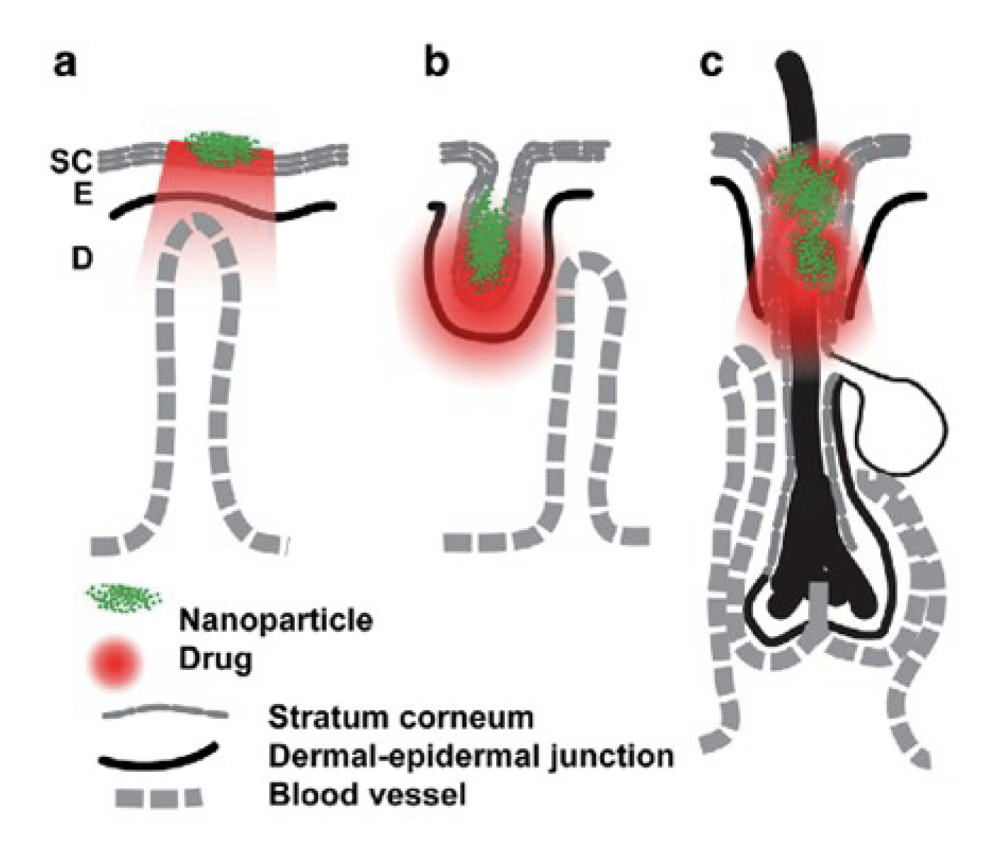

Figure 4. Delivery of nanoparticles into possible sites of skin: (a): stratumcorneum surface; (b): furrows in skin; (c): opening of hair follicles (infundibulum); Stratum corneum (SC); Viable Epidermis (E); Dermis (D) [47]

Applications of polymeric micelles as drug carrier in topical treatment
Topical treatment is an attractive option to cure the cutaneous diseases because of its advantageous including targeting of drugs to the site of disease and reducing of systemic side effects risk of drugs. Thereby, therapy efficiency in skin diseases could be enhanced and high patient compliance is also provided. But, the success of the topical treatment depends on the penetration of drugs into the targeted layers of skin and the achievement of effective drug levels in these skin layers. In this context, the contribution of topical formulation composition on the efficiency of cutaneous drug delivery is considerable high. In most cases, conventional dosage forms could be insufficient to ensure the effective drug concentrations in targeted layers of skin due to poor skin penetration of drugs. Thus, delivery of drugs to target regions of the skin is a great challenge in terms of improving therapeutic aspect.

Numerous attempts have been made to develop novel topical drug delivery systems, including different type of nano carriers that can improve partition and/or drug penetration across skin. Micro- and nano-sized particulate drug carriers have been optimized to carry the drugs to the targeted layers of the skin [52-61]. Micelles are one of the polymeric nano-sized drug carriers particularly used to improve the aqueous solubility of drugs and to enhance permeability of drugs across membranes [62, 63]. Micellar particle technology for transdermal delivery of estradiol and other steroid compounds have been patented for the first time in 1997. Estrasorb® is a lotion type topical product which is consisted of micelles loaded 17β-estradiol since it is commercially available 2003. It was claimed that the amount of estradiol in that micellar carrier has been improved due to increasing the solubility of drug, thereby it was anticipated that micellar carriers act as depot for estradiol in stratum corneum and viable epidermis. It was also indicated that Ostwald ripening observed in micelles have not been occurred in that product, and that product had stabile structures with being three years shelf-life [63].
In recent years, micelles as nano-sized carriers have been also investigated for delivery of other drugs via skin. In these studies, the micellar carriers have been developed for the treatment of psoriasis (tacrolimus and cyclosporine) [64, 65]; and photo-aging (all-trans retinoic acid) [66]; breast cancer (endoxifen) [67]; and skin cancer (oridonin) [68], fungal infections (clotrimazole, econazole nitrate and fluconazole) [18], and acne (benzoyl peroxide) [69], and the skin permeation of drugs from micelles were also examined. In addition, the micellar carriers of quercetin and rutin as antioxidant compounds [70], polymeric micelles loaded sumatriptan for the treatment of pain in migraine [71]; have been optimized and the efficacy of these formulations have been evaluated with in vitro/in vivo studies. In another study, an anti-inflammatory drug was loaded into core of polymeric micelles, which is resulted in delayed drug release and the slow drug permeation due to core and shell structure. Based on that data, it was reported that these structures could be also considered to delay or inhibit dermal delivery of drugs [72]. In other study, when compared to its ethanolic solution, the structures resembling micelles have increased the solubility of a lipophilic compound, resulting the efficient treatment for chronic wound and burn therapy [73]. However, any of the micellar carriers of these drugs have not been approved in clinically yet.
The researchers have also focused on the possible pathways of micelles to pass across skin. It was shown that polymeric micelles provide the localization of drugs in skin layers following hair follicles pathway based on data obtained from confocal laser microscopy. The deposition of micelles into hair follicles, and between coenocytes and in the inter-cluster regions have been shown with confocal microscopy studies, and the micelles have been proposed as potential carrier for targeted delivery to the hair follicles [18, 64, 65].
The studies performed on the development of polymeric micellar carriers for cutaneous drug delivery have been summarized below, and the polymers used in the formulation of micelles and the features of micelles optimized have been given in Table 1.

Cyclosporin

Cyclosporin A is an immunosuppressant and it is currently indicated in the treatment of psoriasis via oral route [74]. Lapteva et al. prepared polymeric micelles using biodegrable and biocompatible diblok copolymers to increase skin delivery of Cyclosporin A for its dermatological use [64]. It was reported that micelles loaded cyclosporin were homogeneous and spherical shape with the range of 25-52 nm particle size and the low aqueous solubility of cycylosporin had been increased about 500 times with micellar carriers. In this study, the localisation of both drugs and copolymer was also investigated using confocal laser scanning microscopy. For this aim, both copolymer and cyclosporin A chemically bounded to fluorescent dyes. Based on the images obtained from confocal laser scanning microscopy, it was reported that micelles were localized between corneocytes and in the inter-cluster regions. The authors also indicated that inter-cluster penetration is likely the preferred transport route of micelles, and that provide enhancement of cutaneous delivery of Cyclosporin A. The authors also emphasized that the efficiency of micellar carriers should be validated in vivo with diseased skin due to the features of psoriatic skin.

Table 1. Micelles prepared for skin delivery in the literature.

Active compounds | Polymers used in the composition of micellar carrier | Method | Size of micelles | Ref.
Clotrimazole  Econazole nitrate  Fluconazole | Amphiphilicmethoxy-poly(ethylene glycol)-hexyl substituted polylactide (MPEG-hexPLA) block copolymers | Sonication / film hidration method | 30-40 nm | [18]
Tacrolimus | Methoxypoly(ethylene glycol)-dihexyl substituted polylactide diblock copolymer | Solvent evaporation method | 10-50 nm | [64]
Cyclosporine | Methoxypoly (ethylene glycol)-dihexyl substituted polylactide diblock copolymer | Solvent evaporation method | 25-52 nm | [65]
Retinoic acid | PEG conjugated phosphatidylethanolamine | NG | 6-20 nm | [66]
Endoxifen | Poly-ԑ-caprolactone with multiple  hydrophilic poly(ethylene glycol) chains mediated by a generation 3 (G3) polyester dendron | NG | 40-50 nm | [67]
Oridonin | Monomethoxy poly(ethylene glycol)-poly(ԑ- caprolactone) | Film hidration method | 25 nm | [68]
Benzoyl peroxide | Poly(ethylene glycol)-block-poly(propylene glycol)-poly(ethylene glycol) | Film method | 25-30 nm | [69]
Quercetin  and Rutin | Poly(ԑ-caprolactone)-b-poly(ethylene glycol) | NG | NG | [70]
Sumatripran | Poly(ethylene glycol)-block-poly(propylene glycol)-poly(ethylene glycol) | Emulsification method | NG | [71]
NG=not given

Tacrolimus
Tacrolimus is also a potent macrolide immunosuppressant compound [75]. The same researchers stated above prepared the polymeric micelles of tacrolimus and evaluated the possibility of delivering tacrolimus into targeted layers of the skin [65]. They showed that the accumulation of tacrolimus in the stratum corneum, viable epidermis, and upper dermis has been increased. Based on confocal laser scanning microscopy data, it was reported that copolymers used in the composition of micelles would not passed through skin and micelles were deposited in hair follicles. They also emphasized that micellar caririers of tacrolimus could be considered as an effective carriers because of having superior efficiency to its conventional ointment formulation.
Sumatriptan
Sumatriptan, 5-hydroxy tryptamine 1D (5-HT1D)-receptor agonist, is used in the treatment of migraine via oral and parenteral administration routes [76]. But, it has low bioavailability problem following due to its presystemic metabolism its oral administration. In addition, nausea or vomiting problem also is observed in migraine attacks which lead to insufficiency in oral treatment. In order to overcome these disadvantageous of oral route, the efficency of transdermal delivery of sumatriptan via micellar carriers have been assessed [71]. Lesitin organogels of sumatriptan composed of thermoreversible micelles were optimized to improve its stability and permeation of sumatriptan across the skin. The authors indicated that optimized formulation was stable without any significant changes at room temperature. Improved topical delivery of sumatriptan has been attributed to improved drug solubility. It was also proposed that the prepared sumatriptan micelles containing lecithin and pluronic were considered to be safe and stable drug delivery system.
Endoxifen
Endoxifen, one of the active metabolite of tamoxifen, was shown to be effective in the prevention and treatment of estrogen-positive breast cancer [77]. However, severe side effects are observed following its oral administration. Thus, the dendron micelles with various surface groups (-NH₂, -COOH, or -Ac) of endoxifen were optimized to increase the localization of endoxifen in the targeted tissue following its topical administration [67]. It was reported that the modification of end-groups of micelles affected the drug loading capacity of micelles, and that was resulted in highest encapsulation efficiency with micelles having –COOH surface end groups. When the skin delivery of endoxifen was examined, it was determined that the dendron micelles increased the permeation of endoxifen across both mouse and human skin and the dendron micelles having - COOH end groups showed the highest endoxifen flux through skin. Based on these results, authors claimed that Dendron micelles could be an effective carrier for the topical delivery of endoxifen as a potential alternative administration route.
Oridonin
Oridonin, a natural tetracycline diterpenoid isolated from Rabdosia rubescens, has been reported to be a potent cytotoxic agent [78]. The micellar carriers of were prepared in order to increase aqueous solubility, and its permeation across excised mouse skin were studied [68]. It was shown that micellar carrier of oridonin had higher transdermal delivery compare to its saturated solution. The authors indicated that the micelles of oridonin could be considered for intravascular administration as a transdermal drug delivery system in cancer chemotherapy.
Clotrimazole, Econazole nitrate and Fluconazole
Clotrimazole, econazole nitrate and fluconazole are azol group antifungal compounds which are widely used with their conventional formulations such as ointment topically [79]. But, the efficiency of the topical antifungal treatment is involved due to low aqueous solubility of drugs. Bachav et al. optimized the miceller carriers of these antifungal drugs to improve the deposition of these antifungals in target layer after application on both porcine and human skin [18]. It was demonstrated that the deposition of econazole in both human and porcine skin was significantly higher than those of its commercial liposome formulation. The authors reported that the micellar carriers may increase targeted follicular delivery according to confocal laser scanning microscopy data.
Benzoyl peroxide

Benzoyl peroxide is one of comedolitics frequently used in the treatment of mild and moderate acne [80]. Although it is commonly used by the patients, has several side effects including skin irritation depending on doses of benzoyl peroxide, skin dryness, contact allergy, burning, scaling, itching and erythema, resulted in poor patient compliance. In addition, the deposition of anti-drugs is required in the pilosebaceous units of the skin for the efficiency of topical acne treatment. BPO loaded polymeric micelles were prepared by thin film hydration method using various solvents to decrease the side effects of benzoyl peroxide and increase deposition of benzoyl peroxide in the pilosebaceous units [69]. They were about 25 nm in hydrodynamic diameter with narrow polydispersity index in the water and had encapsulation efficiency. Confocal laser scanning microscopy studies showed that Nile Red loaded polymeric micelles located into the hair follicles.
Retinoic acid
The topical application of all-trans retinoic acid (ATRA) has been used in the treatment of several dermatological diseases such as photo-aging [81]. Polymeric micelles of retinol has been formulated to improve of photo-stability of retinol. Because retinol is very sensitive to light, heat, and oxidizing agents. Thus, ATRA entrapped in polymeric micelles with various PEG and PE structures have been prepared [66]. The authors reported that micelles of ATRA composed of PEG (molecular weight of 750 Da) and to conjugate of dipalmitoyl phosphatidylethanolamine (PEG750-DPPE) showed the highest entrapment efficiency (82.7%) among the tested micelles. It was demonstrated that up to 87% of ATRA were measured following the storage of the PEG750-DPPE micelle solution in ambient media for 28 days. Based on that data it was proposed that PEG750-DPPE micelles of ATRA as an alternative carrier for the formulation of cosmeceutical formulations due to its improved photo-stability.
Quercetin and Rutin
The flavonoids rutin and quercetin have been described as cell-protecting agents because of their antioxidant, antinociceptive, and anti-inflammatory actions [82]. Micellar carriers of quercetin and rutin which are antioxidant compounds have been prepared and the permeation of these drugs across skin using Franz diffusion cells was examined in vitro [70]. The aqueous solutions of both quercetin and rutin were used as the control groups. The authors showed that quercetin and rutin loaded micelles had more efficient skin permeation than those of the control groups. In this study, safety assessment of quercetin and rutin loaded micelles on skin was studied to evaluate application possibility of these polymeric micelles to cosmetics. It was indicated that any adverse symptoms were not observed following the application.

Conclusions

Topical treatment of most skin disorders would be useful in terms of delivering drugs to the diseased layers of skin and preventing systemic side effects of drugs. However, skin -particularly its stratum corneum layer- is an excellent barrier to be provided for the effective drug concentrations in its deeper layers in cutaneous drug delivery. The conventional dosage forms such as creams, gels could be unsatisfactory in the topical treatment due to the poor penetration of drugs into targeted layers of skin and inadequately deposition in the skin, resulting in low topical bioavailability. Thus, development of novel drug carries is an important challenge for delivering of drugs topically to treat topical diseases. In recent years, nano-sized drug carriers are used as a popular strategy to delivering the drugs into skin. The micelles are also considered as one of the drug carriers to improve the delivery of drugs via skin. Improved cutaneous targeted delivery of several drugs has been observed for these systems when compared to conventional topical formulations in the studies. Based on the recent findings, micelles seems to be promising carriers which provide the deposition of some drugs, in particular superficial layers of the skin and hair follicles.

REFERENCES
- D. Thassu, Y. Pathak, M. Deleers, in Nanoparticulate Drug-Delivery Systems: An Overview, D. Thassu, M. Deleers, Y. Pathak, Eds., Informa Healthcare Inc., New York, The USA, 2007, p.1
- V.P. Torchilin, Pharm Res. 24 (2007) 1-16
- V. Gómez-Vallejo, M. Jiménez-González, J. Llop, T. Reese, in New Molecular and Functional Imaging Techniques, A. Luna, J.C. Vilanova, L.C.H. Cruz Jr, S.E. Rossi Eds., Springer, New York, The USA, 2014, p.491
- D.L. Garrec, M. Ranger, J.C. Leroux, Am J Drug Deliv 2 (2004) 15-42
- M.C. Jones, J.C. Leroux, Eur J Pharm Biopharm 48 (1999) 101-111
- V.P. Torchilin, Expert Opin Ther Pat 15 (2005) 63-75
- V.P. Torchilin, J Control Release 73 (2001) 137-172
- K. Kataoka, A. Harada, Y. Nagasaki, Adv Drug Delivery Rev 47 (2001) 113-131
- M.G. Carstens, C.J.F. Rijcken, C.F. Nostrum, W.E. Hennink, in Pharmaceutical Micelles: Combining Longevity, Stability and Stimuli Sensitivity, V. Torchilin Ed., Springer-Science&Business Media, New York, The USA, 2008, p.263
- A. Richter, C. Olbrich, M. Krause, J. Hoffmann, T. Kissel, Eur J Pharm Biopharm 75 (2010) 80-89
- L. Song, Y. Shen, J. Hou, L. Lei, S. Guo, C. Qian, Colloids Surf A Physicochem Eng Asp 390 (2011) 25-32
- Z. Sezgin, N. Yüksel, T. Baykara, Int J Pharm 332 (2007) 161-167
- G. Gaucher, P. Satturwar, M.C. Jones, A. Furtos, J.C. Leroux, Eur J Pharm Biopharm 76 (2010) 147-158
- T. Kanazawa, H. Taki, K. Tanaka, Y. Takashima, H. Okada, Pharm Res 28 (2011) 2130-2139
- E. Kahraman, A. Karagöz, S. Dinçer, Y. Özsoy, J Biomed Nanotech 11 (2015) 890-898
- C.D. Tommaso, A. Torriglia, P. Furrer, F. Behar-Cohen, R. Gurny, M. Möller, Int J Pharm 416 (2011) 515-524
- I. Pepiæ, J. Lovriæ, J. Filipoviæ-Grèiæ, Chem Biochem Eng Q 26 (2012) 365–377
- Y.G. Bachhav, K. Mondon, Y.N. Kalia, R. Gurny, M. Möller, J Control Release 153 (2011) 126-132
- P. Valenzuela, J.A. Simon, Maturitas 73 (2012) 74–80
- H. Lee, P.L. Soo, J. Liu, M. Butler, C. Allen, in Polymeric Micelles For Formulation of Anti-Cancer Drugs, M.M. Amiji Ed., CRC Press Taylor & Francis Group, London, UK, 2007, p.317
- S. Biswas, O.S. Vaze, S. Movassaghian, V.P. Torchilin, in Polymeric Micelles for the Delivery of Poorly Soluble Drugs, D. Douroumis, A. Fahr Eds., John Wiley & Sons, Ltd., New York, The USA, 2013, p.411
- V.K. Mourya, N. Inamdar, R.B. Nawale, S.S. Kulthe, Indian J Pharm Educ 45 (2011) 128-138
- G. Gaucher, M.H. Dufresne, V.P. Sant, N. Kang, D. Mayssinger, J.C. Leroux, J Control Release 109 (2005) 169-188
- L. Capretto, S. Mazzitelli, E. Brognara, I. Lampronti, D. Carugo, X. Zhang, R. Gambari, C. Nastruzzi, Int J Nanomedicine 7 (2012) 307-324
- C. Allen, D. Maysinger, A. Eisenberg, Colloids Surf B Biointerfaces 16 (1999) 3-27
- J. Zhang, P.X. Ma, Angew Chem Int Ed Engl 48 (2009) 964–968
- Y.I. Jeong, S.H. Kim, T.Y. Jung, I.Y. Kim, S.S. Kang, Y.H. Jin, H.H. Ryu, H.S. Sun, S. Jin, K.K. Kim, K.Y. Ahn, S. Jung, J Pharm Sci 95 (2006) 2348-2360
- L. Bromberg, J Control Release 128 (2008) 99-112
- S.Y. Kim, I.G. Shin, Y.M. Lee, C.S. Cho, Y.K. Sung, J Control Release 51 (1998) 13-22.

- F. Kohori, K. Sakai, T. Aoyagi, M. Yokoyama, Y. Sakurai, T. Okano, J Control Release 55 (1998) 87-98
- Y. Kakizawa, K. Kataoka, Adv Drug Deliv Rev 54 (2002) 203-222
- R.J. Hunter, Zeta Potential In Colloid Science Principles And Applications, Academic Press Inc., London, UK, 1981, P.219
- A. Williams, Transdermal and Topical Drug Delivery: From Theory to Clinical Practice, Pharmaceutical Press, London, UK, 2003, p.1
- R.H. Guy and J. Hadgraft, Transdermal Drug Delivery, Marcel Dekker, Inc., New York, USA, 2003, p. 1
- J Hadgraft, Int J Pharm 224 (2001) 1-18
- R.O. Potts, M.L. Francoeur, J Invest Dermatol 96 (1991) 495-499
- P.M. Ellias, J Control Release 15 (1991)199-208
- R.H. Guy Transdermal Drug Delivery, In: Drug Delivery, (Handbook of Experimental Pharmacology), M. Schäfer- Korting (Ed.), Springer Verlag, Berlin, Germany, 2010 p.399
- J. Hadgraft, Lane M.E., Int J Pharm 305 (2005) 2-12
- J. Hadgraft, Skin Pharmacol Appl Skin Physiol 14 (Suppl 1) (2001) 72-81
- R.J. Sheuplein, J Invest Dermatol 45 (1965) 334-346
- B.W. Barry, Adv Drug Deliv Rev 54 (Suppl 1) (2002) 31-40
- J. Lademann, F. Knorr , H. Richter , U. Blume-Peytavi, A. Vogt, C. Antoniou, W. Sterry, A. Patzelt, Skin Pharmacol Physiol 21 (2008) 150-155
- F. Knorr, J. Lademann, A. Patzelt, W. Sterry, U. Blume-Peytavi, A. Vogt, Eur J Pharm Biopharm 71 (2009)173-180
- J. Lademann, H. Richter, S. Schanzer, F. Knorr, M. Meinke, W. Sterry, A Patzelt, Eur J Pharm Biopharm 77 (2011) 465-468
- A. Patzelt, J. Lademann, Expert Opin Drug Deliv 10 (2013) 787-797
- T.W. Prow, J.E. Grice, L.L. Lin, R. Faye, M. Butler, W. Becker, E.M. Wurm, C. Yoong, T.A. Robertson, H.P. Soyer, M.S. Roberts, Adv Drug Deliv Rev 63 (2011) 470-491.
- C.S. Campbell, L.R. Contreras-Rojas, M.B. Delgado-Charro, R.H. Guy, J Control Release 162 (2012) 201-207.
- M.E. Lane, J Microencapsulation 28 (2011) 709-716
- A.C. Watkinson, A.L. Bunge, J. Hadgraft, M.E. Lane, Pharm Res 30 (2013) 1943-1946
- B. Baroli, J Pharm Sci 99 (2010) 21-50
- D. Papakostas, F. Rancan, W. Sterry, U. Blume-Peytavi, A. Vogt, Arch Dermatol Res 303 (2011) 533-550.
- M. Gupta, U. Agrawal, S.P. Vyas, Expert Opin Drug Deliv 9 (2012) 783-804
- J. Kristl, K. Teskac, P.A. Grabnar, J Biomed Nanotechnol 6 (2010) 529-542.
- A. Schroeter, T. Engelbrecht R.H., Neubert, A.S. Goebel, J Biomed Nanotechnol 6 (2010) 511-528
- R.H. Neubert, Eur J Pharm Biopharm 77 (2011) 1-2
- G. Cevc, Adv Drug Deliv Rev 56 (2004)675-711
- M.J. Choi and H.I. Maibach, Skin Pharmacol Physiol 18 (2005) 209-219
- H.A. Benson, Curr Drug Delivery, 6 (2009) 217-226
- A. Kogan and N. Garti, Adv Colloid Interface Sci 123-126 (2006), 369-385
- B. Godin and E. Touitoi, Crit Rev Ther Drug 20 (2003) 63-102
- S. Güngör, J Nanomed Nanotechnol 5 (2014) 101
- R.W. Lee, D.B. Shenoy, R. Sheel, Micellar Nanoparticles: Applications for Topical and Passive Transdermal Drug Delivery, In: Handbook of Non-Invasive Drug Delivery Systems, V.S. Kulkarni (Ed.), Elsevier Inc., Oxford, UK 2010, p37
- M. Lapteva, V. Santer, K. Mondon, I. Patmanidis, G. Chiriano, L. Scapozza, R. Gurny, M. Möller, Y.N. Kalia, J Control Release 196 (2014) 9-18
- M. Lapteva, K. Mondon, M. Möller, R. Gurny, Y.N. Kalia, Mol Pharm 11 (2014) 2989-3001
- A. Wichit, A, Tangsumranjit, T, Pitaksuteepong, N. Waranuch, AAPS PharmSciTech 13 (2012) 336-343
- Y. Yang, R.M. Pearson, O. Lee, C.W. Lee, R.T. Chatterton, S.A. Khan, S. Hong. Adv Funct Mater 24 (2014) 2442-2449
- B. Xue, Y. Wang, X. Tang, P. Xie, Y. Wang, F. Luo, C. Wu, Z. Qian, J Biomed Nanotechnol 8 (2012) 80-89
- E. Kahraman, Y. Özsoy, S. Güngör, World Congress of the International Society for Biophysics and Imaging of the Skin (ISBS), Foxwoods Pequot Resort Mystic, CT, USA, 2014, O09
- G.N. Lim, S.Y. Kim, M.J. Kim, S.N. Park, Polymer Korea 36 (2012) 420-426
- V. Agrawal, S. Gupta, S. Ramteke, P. Trivedi, AAPS PharmSciTech 11 (2010) 1718-1725
- J. Djordjevic, B. Michniak, K.E. Uhrich, AAPS PharmSci 5 (2003) E26
- M.C. Bonferoni, G. Sandri, E. Dellera, S. Rossi, F. Ferrari, M. Mori, C. Caramella, Eur J Pharm Biopharm 87 (2014) 101-106
- H. Liu, Y. Wang, Y. Lang, H. Yao, Y. Dong, S. Li, J Pharm Sci 98 (2009) 1167-1176
- T. Kino, H. Hatanaka, M. Hashimoto, M. Nishiyama, T. Goto, M. Okuhara, M. Koshaka, H. Aoki, H. Imanaka. J Antibiot 10 (1987) 1249-1255
- S.D. Silberstein, D.A. Marcus, Expert Opin Pharmacother 14 (2013) 1659-1667.
- Y.C. Lim, Z. Desta, D.A. Flockhart, T.C. Skaar, Cancer Chemother Pharmacol 55 (2005) 471-478
- S. Wang, Z. Zhong, J. Wan, W. Tan, G. Wu, M. Chen, Y. Wang, Am J Chin Med 41 (2013) 177-196
- M.J. Dolton, A.J. McLachlan. Curr Opin Infect Dis 27 (2014) 493-500
- A. Krautheim, H.P.M. Gollnick, Clin Dermatol 22 (2004) 398–407
- S. Cho, L. Lowe, T.A. Hamilton, G.J. Fisher, J.J. Voorhees, S. Kang, J Am Acad Dermatol 53 (2005) 759-764
- M.I. Azevedo, A.F. Pereira, R.B. Nogueira, F.E. Rolim, G.A.C. Brito, D. Viviana, T. Wong, R.C.P. Lima-Júnior, R.A. Ribeiro, M.L. Vale, Molecular Pain 9 (2013) 53-67

